# Final Year Project Weekly Assignment 1

Name: Pranaya Pradhan

Group: C4

Internal Supervisor: Rohit Pandey

External Supervisor: Shekhar Timisina

# Detailed Feature List

## For Website (Admin/Editor)

* Admin
* User
  + - Username
    - First Name
    - Last Name
    - Email
    - User Password
    - Actions:
      * Add the Editor
      * Update the Editor detail
      * Delete the Editor (if required)
* Admin and Editor
* News Feeds
* News Title
* News Type
* News Description
* News Image
* Date
* Actions:
  + Add the News
  + Update the News
  + Delete the News (if required)
* Club Detail
* Club Name
* Club Description
* Club Founded Date
* Club Address
* Club Email
* Club Division
* Club Affiliation
* Home Jersey Color
* Away Jersey Color
* Club Sponsor
* Kit Sponsor
* Club Logo
* Actions:

- Adds the Club details

- Update/Edit the Club details

- Delete the Club detail (if required

* Player Detail
* First Name
* Last Name
* Date of Birth
* Place of Birth
* Gender
* Position
* Country
* Image
* Club Id
* Status (active/inactive)
* Actions:
  + Adds the Player details
  + Update/Edit the Players details
  + Delete the Player details (if required)

* Tournaments
  + - Tournament Id
    - Tournament Name
    - Tournament Type
    - Season
    - Title Sponsor
    - Organizers
    - Actions:
  + Adds the tournaments detail
  + Edit/Update the tournaments detail
  + Delete the tournaments detail
* Fixtures/Match
* Club 1
* Club 2
* Date
* Kick Off Time
* Venue
* Club 1 Score
* Club 2 Score
* Club 1 Result
* Club 2 Result
* Status (Played/Not Yet Played)
* Actions:
* Adds the match/fixtures detail
* Edit/Update the fixture detail
* Delete the fixture detail
* Statistics
* Highest Scorer
  + Player Id
  + Player First Name
  + Player Last Name
  + Club
  + Total Goals
* Red Card
  + Id
  + Player Name
  + Club
  + Total Cards
* Yellow Card
  + Id
  + Player Name
  + Club
  + Total Cards
* Clean Sheets
  + Id
  + Player Name
  + Club
  + Total Number of Clean Sheets
* Actions:
* Adds the Statistics detail
* Edit/Update the Statistics Detail
* Delete the Statistics Detail

## For Mobile App (User)

* News Feeds
* News Title
* News Description
* News Type
* News Image
* Date
* Actions:
  + Views the news feeds
* Club Detail
* Club Name
* Club Description
* Club Logo
* Club Address
* Club Email
* Club Telephone
* Club Affiliation
* Actions:

- Views the Club Detail

* Player Detail
* Player Name
* Date of Birth
* Place of Birth
* Position
* Jersey No
* Nationality
* Image
* Club Id
* Status (activate/deactivate)
* Actions:
  + Views the Player Detail

* Fixtures
* Club 1
* Club 2
* Date
* Time
* Venue
* Result
* Actions:
* Views the Fixtures
* Statistics
* Views Points Table
* Highest Scorer
  + Id
  + Player Name
  + Club
  + Total Goals
* Red Card
  + Id
  + Player Name
  + Club
  + Total Cards
* Yellow Card
  + Id
  + Player Name
  + Club
  + Total Cards
* Actions:
* Views the Statistics

# Wire Frame of each feature

## For Website (Admin/Editor)

### Login

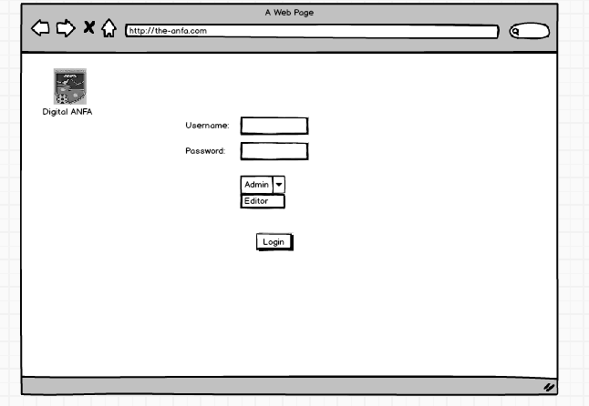

Figure 1 Web Login

### News Feed

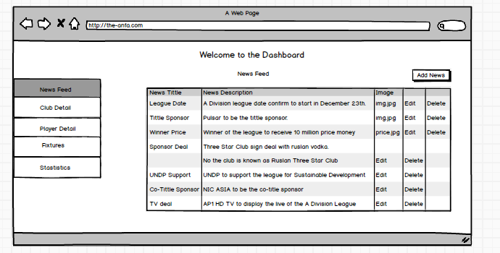

Figure 2 News Feed

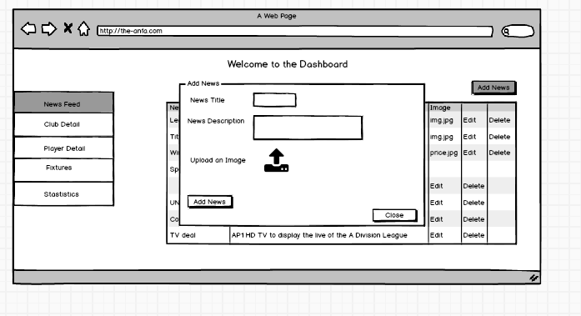

Figure 3 Add Action of News Feed Table

### Club Detail

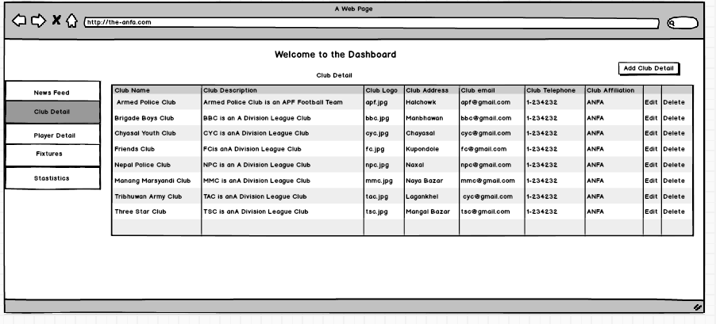

Figure 4 Club Detail Table

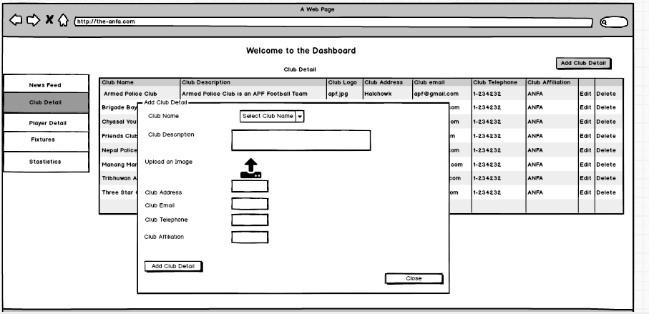

Figure 5 Action to Add Club Detail

### Player Detail

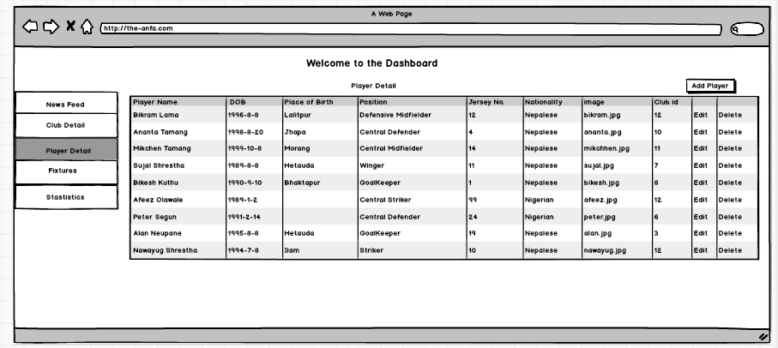

Figure 6 Player Detail Table

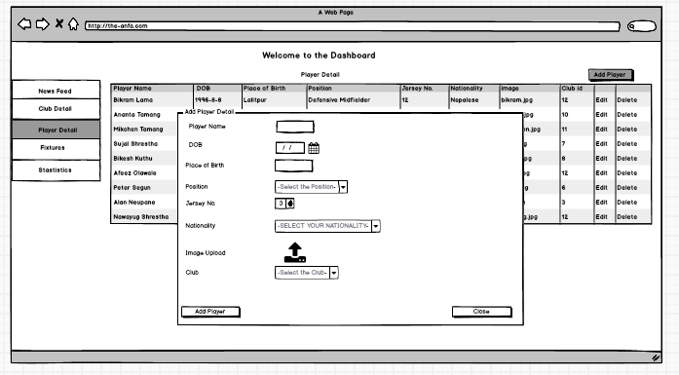

Figure 7 Action of Player Detail Table

### Fixtures

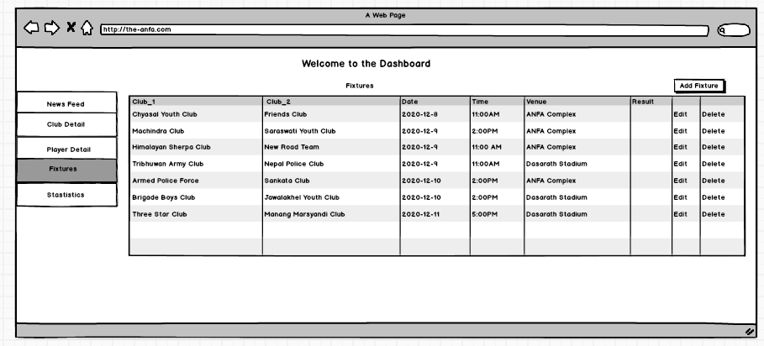

Figure 8 Fixture Table

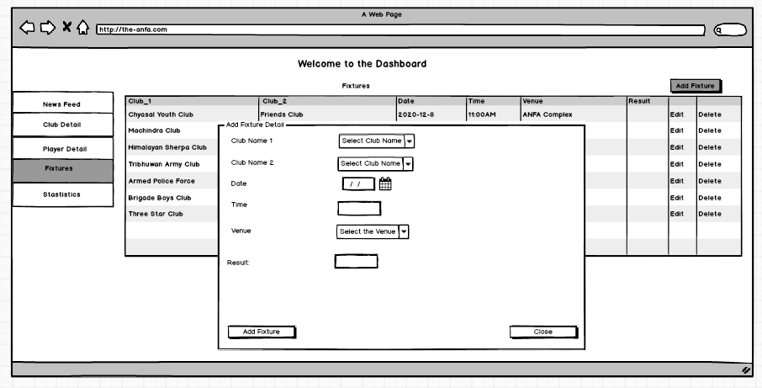

Figure 9 Action to add in Fixtures Table

### Statistics

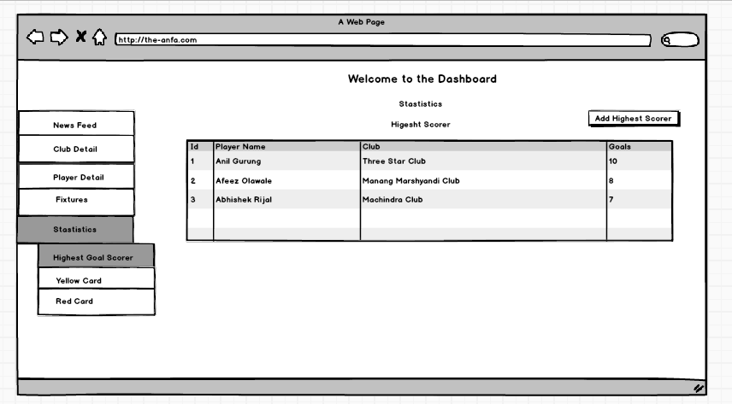

Figure 10 Statistics Table of Highest Scorer

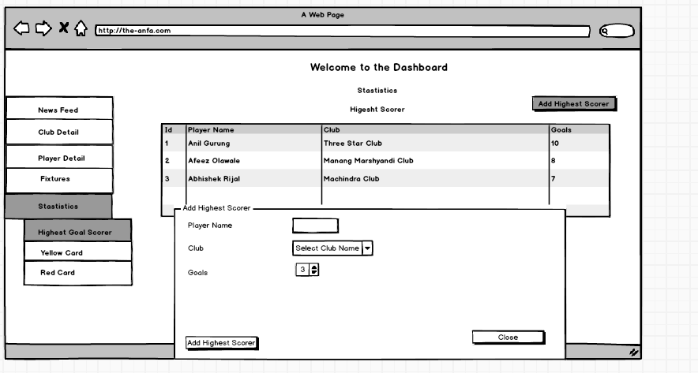

Figure 11 Action to add Highest Scorer

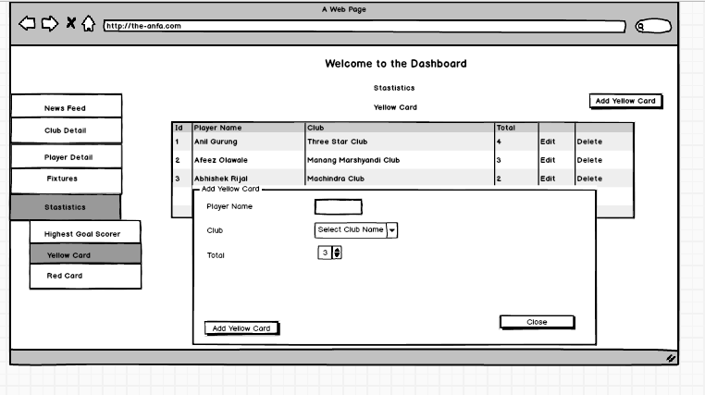

Figure 12 Statistics Table for Yellow Card

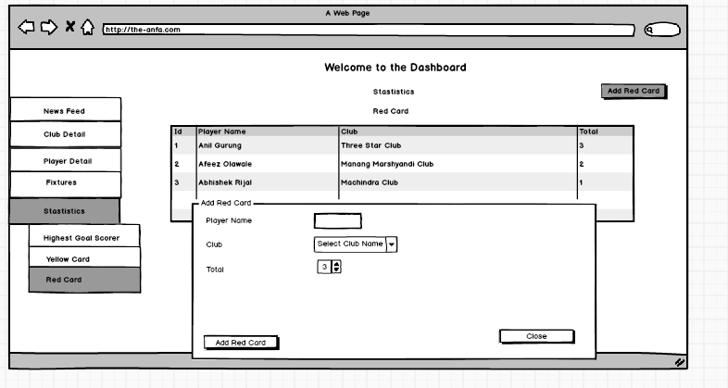

Figure 13 Add Action for Yellow Card



Figure 14 Statistics for Red Card

## For Mobile Application (User)

### Splash Screen

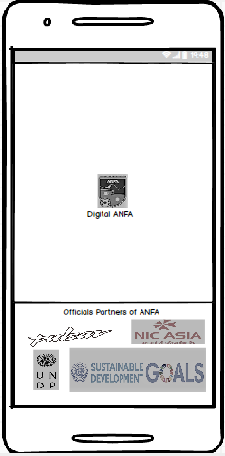

Figure 15 Splash Screen

### News Feed Screen

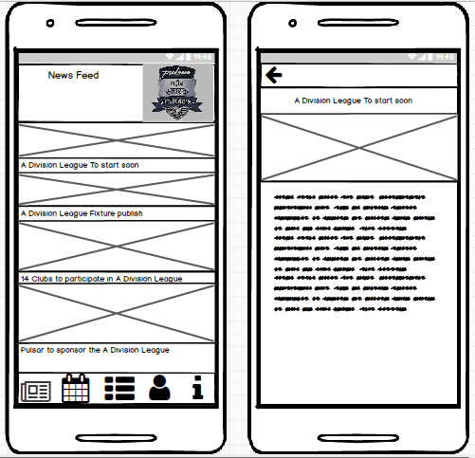

Figure 16 News Feed Screen

### Fixtures Screen

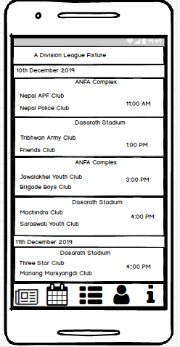

Figure 17 Fixture Screen

### Statistics Screen

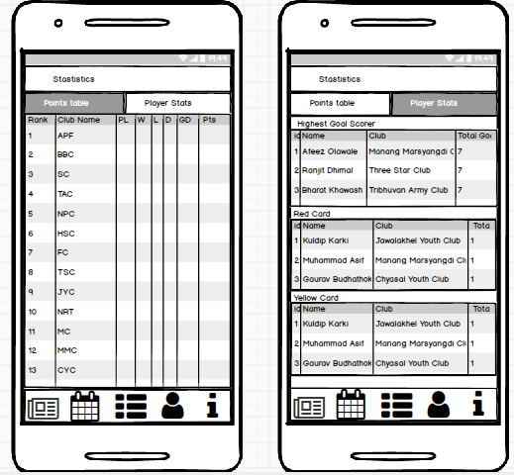

Figure 18 Statistics

### Club Profile Screen

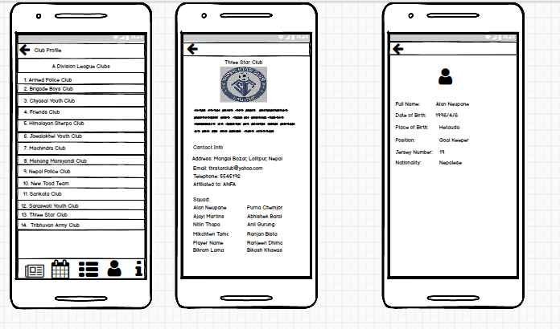

Figure 19 Club Profile

### About Us Screen

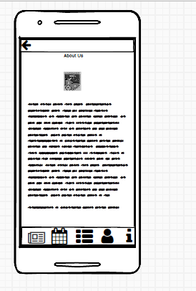

Figure 20 About Us Screen

# UML Diagram

## Use Case



Figure 21 Overall Use Case Diagram

## High Level Description

### Access into Dashboard

|  |  |
| --- | --- |
| Use Case: | Access to dashboard |
| Actors: | Admin, Editor |
| Description: | An Actors logs in and get access to the dashboard. |

### Adds the Editor

|  |  |
| --- | --- |
| Use Case: | Adds the editor |
| Actors: | Admin |
| Description: | An Actor adds the editor. |

### Keeps News in Feed

|  |  |
| --- | --- |
| Use Case: | Keeps News in Feed |
| Actors: | Admin, Editor |
| Description: | The actors adds news in the news feed section. |

### Upload Clubs and Players Detail

|  |  |
| --- | --- |
| Use Case: | Upload Clubs and Players Detail |
| Actors: | Admin, Editor |
| Description: | The actors uploads the clubs and player details. |

### Records the Statistics

|  |  |
| --- | --- |
| Use Case: | Record the Statistics |
| Actors: | Admin, Editor |
| Description: | The actors records the statistics of the games. |

### Update the Fixtures

|  |  |
| --- | --- |
| Use Case: | Update the Fixtures |
| Actors: | Admin, Editor |
| Description: | The actors updates the fixtures of the match |

### Reads the news

|  |  |
| --- | --- |
| Use Case: | Reads the news |
| Actors: | User |
| Description: | The user reads the news about the tournament. |

### Get Club Detail

|  |  |
| --- | --- |
| Use Case: | Get Club Detail |
| Actors: | User |
| Description: | The user get the information of the Football Club. |

### Gets Player Detail

|  |  |
| --- | --- |
| Use Case: | Gets Player Detail |
| Actors: | User |
| Description: | The user gets brief detail of the players. |

### Views Statistics

|  |  |
| --- | --- |
| Use Case: | Views the Statistics |
| Actors: | User |
| Description: | An user views the statistics of the tournament. |

### Knows the fixtures

|  |  |
| --- | --- |
| Use Case: | Knows the fixtures |
| Actors: | User |
| Description: | An user get information about the fixtures. |

### For Web(Admin/Editor)

### Use Case of News Feed

|  |  |
| --- | --- |
| Name: | Keep News in Feed |
| Actors: | Editor, Admin |
| Description: | The actors keep the news in the news feed section. He/she can add, edit and delete the news. |



Figure 22 Add News



Figure 23 Edit News

Figure 24 Delete the News

### Use Case of Fixtures

|  |  |
| --- | --- |
| Name: | Update the fixtures |
| Actors: | Editor, Admin |
| Description: | The actors have permission to update the fixture of the matches. |



Figure 25 Add Fixtures



Figure 26 Edit the fixtures



Figure 27 Delete the Fixture

### Use Case of Club Detail

|  |  |
| --- | --- |
| Name: | Upload Club and Player Detail |
| Actors: | Editor, Admin |
| Description: | The actors have right to upload the club detail. Similarly, he/she can edit as well delete the detail if require. |



Figure 28 Add Club Detail



Figure 29 Edit Club Detail



Figure 30 Delete Club Detail

### Use Case of Player Detail

|  |  |
| --- | --- |
| Name: | Upload Club and Player Detail |
| Actors: | Editor, Admin |
| Description: | The actors have right to upload the player detail. Similarly, he/she can edit as well delete the detail if require. |

Figure 31 Use Case of Add Player Detail



Figure 32 Use Case of Edit Player Detail

Figure 33 Delete Player Detail

### Use Case of Statistics

|  |  |
| --- | --- |
| Name: | Upload Club and Player Detail |
| Actors: | Editor, Admin |
| Description: | The actors have an ability to record the statistics of the matches. |



Figure 34 Add Statistics



Figure 35 Edit Statistics



Figure 36 Delete Statistics

### For Mobile (User)

### 3.2.6. Use Case of News Feed

|  |  |
| --- | --- |
| Name: | Reads the News in Feed |
| Actors: | User |
| Description: | The actors view the news tittle and images as well as can read the news. |



Figure 37 Use Case of News Feed

### 3.2.7. Use Case of Fixtures

|  |  |
| --- | --- |
| Name: | Knows the Fixtures |
| Actors: | User |
| Description: | The actors can know the fixture of the match of tournament. |



Figure 38 Use Case of Fixtures

### 3.2.8. Use Case of Statistics

|  |  |
| --- | --- |
| Name: | Views Statistics |
| Actors: | User |
| Description: | The actors have right to statistics of the match. |



Figure 39 Use Case of Statistics

### 3.2.9. Use Case of Club Profile

|  |  |
| --- | --- |
| Name: | Gets Club and Player Detail |
| Actors: | User |
| Description: | The actors gets the detail of the clubs and players. |

Figure 40 Use Case of Club Profile

# Introduction

## Introduction to Topic

## Current Scenario

## Problem Domain

## Scope

## Aims and Objectives

# Background

## Project Elaboration

## Terms/Definition

## System Architecture

## Feature

## Wireframe

## Similar System

## Comparison

# Conclusion